EX No:1 | EDA-Data Cleaning

Aim:

Algorithm:

Program:
import pandas as pd
import numpy as np
import matplotlib.pyplot as plt

# CRISP-DM FRAMEWORK
# ============================================================

# 1. BUSINESS UNDERSTANDING
# Objective:
# Analyze hotel booking patterns, customer behavior,
# cancellation trends and seasonal demand.

# 2. DATA UNDERSTANDING

df = pd.read_csv("hotel_bookings.csv")

print(df.head())
print(df.shape)
print(df.info())
print(df.describe())
print(df.isnull().sum())
print(df.duplicated().sum())

# 3. DATA PREPARATION

df.drop_duplicates(inplace=True)
df.drop(columns='company', inplace=True)

df['agent'] = df['agent'].fillna(df['agent'].median())
df['country'] = df['country'].fillna(df['country'].mode()[0])
df['children'] = df['children'].fillna(0)

df['reservation_status_date'] = pd.to_datetime(df['reservation_status_date'])

df['total_nights'] = df['stays_in_weekend_nights'] + df['stays_in_week_nights']
df['total_guests'] = df['adults'] + df['children'] + df['babies']

# 4. MODELING (EDA)

df['hotel'].value_counts().plot(kind='bar')
plt.title("Hotel Type")
plt.show()

df['is_canceled'].value_counts().plot(kind='bar')
plt.title("Booking Cancellation")
plt.show()

df['arrival_date_month'].value_counts().plot(kind='bar')
plt.title("Monthly Bookings")
plt.show()

df['country'].value_counts().head(10).plot(kind='bar')
plt.title("Top Booking Countries")
plt.show()

corr = df.select_dtypes(include='number').corr()

plt.figure(figsize=(10,8))
plt.imshow(corr)
plt.colorbar()
plt.xticks(range(len(corr.columns)),corr.columns,rotation=90)
plt.yticks(range(len(corr.columns)),corr.columns)
plt.title("Correlation Heatmap")
plt.show()

# 5. EVALUATION
print("Business insights generated successfully.")

# 6. DEPLOYMENT
print("Insights can be deployed through dashboards.")

# SEMMA FRAMEWORK
# ============================================================

# SAMPLE

df = pd.read_csv("hotel_bookings.csv")

# EXPLORE

print(df.head())
print(df.info())
print(df.describe())
print(df.isnull().sum())

# MODIFY

df.drop_duplicates(inplace=True)
df.drop(columns='company', inplace=True)

df['agent'] = df['agent'].fillna(df['agent'].median())
df['country'] = df['country'].fillna(df['country'].mode()[0])
df['children'] = df['children'].fillna(0)

df['reservation_status_date']=pd.to_datetime(df['reservation_status_date'])

df['total_nights']=df['stays_in_weekend_nights']+df['stays_in_week_nights']
df['total_guests']=df['adults']+df['children']+df['babies']

# MODEL

df['hotel'].value_counts().plot(kind='bar')
plt.show()

df['is_canceled'].value_counts().plot(kind='bar')
plt.show()

df['arrival_date_month'].value_counts().plot(kind='bar')
plt.show()

df['country'].value_counts().head(10).plot(kind='bar')
plt.show()

corr=df.select_dtypes(include='number').corr()

plt.figure(figsize=(10,8))
plt.imshow(corr)
plt.colorbar()
plt.xticks(range(len(corr.columns)),corr.columns,rotation=90)
plt.yticks(range(len(corr.columns)),corr.columns)
plt.show()

# ASSESS

print("Patterns and trends successfully identified.")

# KDD FRAMEWORK
# ============================================================

# SELECTION

df=pd.read_csv("hotel_bookings.csv")

# PREPROCESSING

print(df.info())
print(df.isnull().sum())
print(df.duplicated().sum())

df.drop_duplicates(inplace=True)
df.drop(columns='company', inplace=True)

df['agent']=df['agent'].fillna(df['agent'].median())
df['country']=df['country'].fillna(df['country'].mode()[0])
df['children']=df['children'].fillna(0)

# TRANSFORMATION

df['reservation_status_date']=pd.to_datetime(df['reservation_status_date'])

df['total_nights']=df['stays_in_weekend_nights']+df['stays_in_week_nights']
df['total_guests']=df['adults']+df['children']+df['babies']

# DATA MINING

df['hotel'].value_counts().plot(kind='bar')
plt.show()

df['is_canceled'].value_counts().plot(kind='bar')
plt.show()

df['arrival_date_month'].value_counts().plot(kind='bar')
plt.show()

df['country'].value_counts().head(10).plot(kind='bar')
plt.show()

corr=df.select_dtypes(include='number').corr()

plt.figure(figsize=(10,8))
plt.imshow(corr)
plt.colorbar()
plt.xticks(range(len(corr.columns)),corr.columns,rotation=90)
plt.yticks(range(len(corr.columns)),corr.columns)
plt.show()

# INTERPRETATION

print("Knowledge discovered from the dataset has been interpreted to support hotel business decisions.")
Output:
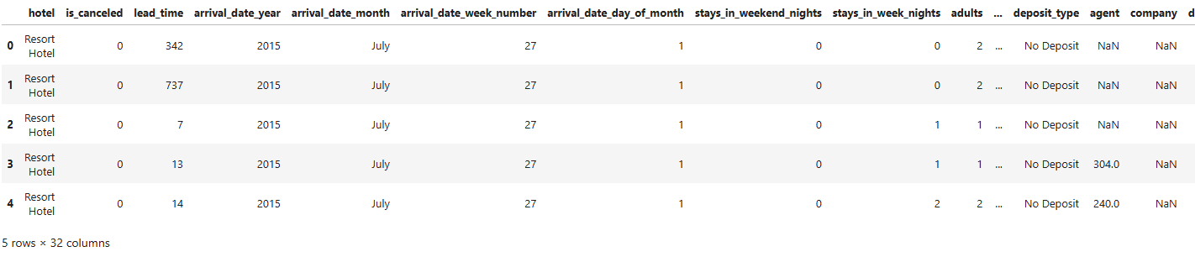

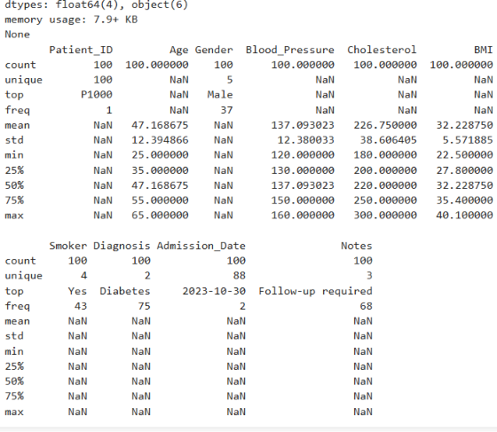
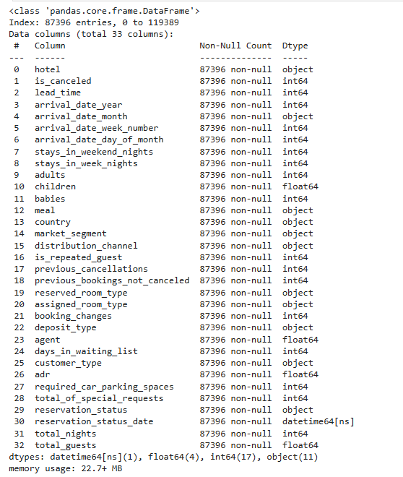
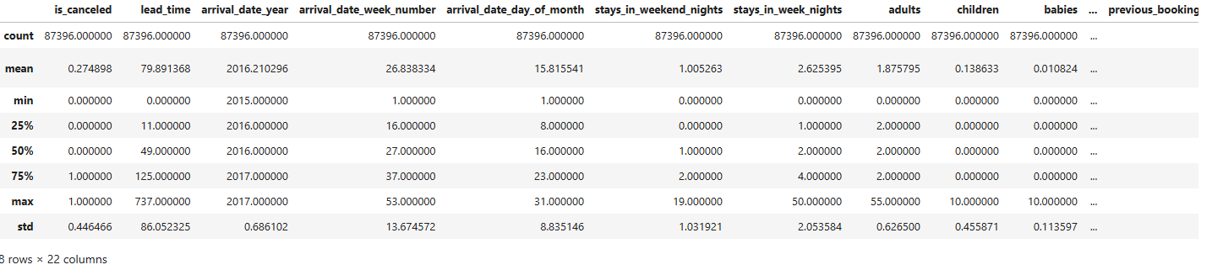
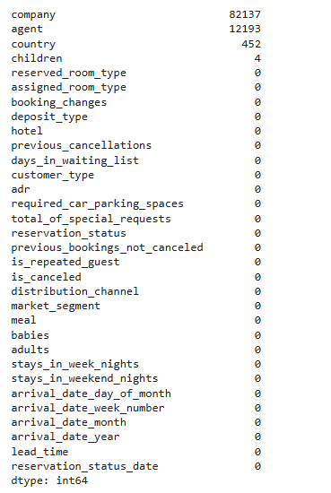
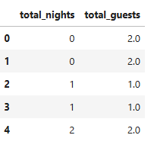

Result:

